SYDNEY WESTERN CITY PLANNING PANEL ASSESSMENT REPORT

Panel Number: | PPSSWC-336.
Application Number: | 2023/284/1.
Local Government Area: | Camden.
Development: | Alterations and additions to Camden Civic Centre, including construction of a new building entry, extension of the building foyer, internal refurbishment and reconfiguration, erection of signage, removal of six trees and landscaping within the building curtilage and Memorial Garden.
Capital Investment Value: | $7,854,000.00
Site Address(es): | 40-46 Oxley Street Camden NSW 2570
Applicant: | Mr Philip Moore, Melocco & Moore
Owner(s): | Camden Council
Date of Lodgement: | 26 May 2023
Number of Submissions: | Three (two objecting to the development and one in support but raising matters for consideration).
Number of Unique Objections: | Three
Classification: | Regionally significant
Recommendation: | Approve with conditions.
Regionally Significant Development Criteria (Schedule 6 of State Environmental Planning Policy (Planning Systems) 2021): | Council related development over $5 million
List of All Relevant Section 4.15(1)(a) Matters: | - State Environmental Planning Policy (Planning Systems) 2021.  - State Environmental Planning Policy (Resilience and Hazards) 2021.  - State Environmental Planning Policy (Industry and Employment) 2021.  - State Environmental Planning Policy (Biodiversity and Conservation) 2021.  - Camden Local Environmental Plan 2010.  - Camden Development Control Plan 2019.
List all Documents Submitted with this Report for the Panel’s Consideration: | - Assessment report.  - Attachment 1 - Camden Local Environmental Plan 2010 assessment table.  - Attachment 2 - State Environmental Planning Policy (Industry and Employment) 2021 assessment table.  - Attachment 3 - Camden Development Control Plan 2019 assessment table.  - Attachment 4 - Recommended conditions.  - Attachment 5 - Proposed plans.  - Attachment 6 - Submissions.
Development Standard Contravention Request(s): | Nil.
Summary of Key Submission Issues: | - Need for the proposed upgrades and other priority works within the LGA.  - Concerns about the changes to the Memorial Park and sensitivity to existing cairn, stones and paving being retained and re-used.  - Public art installations and signage on John Street have regard to HCA.  - Finishes palette, modern style, signage and additions to the building unsympathetic within the HCA.  - Insufficient landscaping and replacement tree canopy planting.  - Insufficient detail about John Street including perspectives.
Report Prepared By: | Ali Hammoud, Consultant Planner - NSW Civic Services
Report Date: | 22 November 2023.

Summary of Section 4.15 Matters

Yes
Have all recommendations in relation to relevant Section 4.15 matters been summarised in the Executive Summary of the assessment report?

Legislative Sections Requiring Consent Authority Satisfaction

Yes
Have relevant sections in all applicable environmental planning instruments where the consent authority must be satisfied about a particular matter been listed and relevant recommendations summarised in the Executive Summary of the assessment report?

Development Standard Contraventions

 | Yes | N/A
If a written request for a contravention to a development standard has been received, has it been attached to the assessment report?

Special Infrastructure Contributions

 | Yes | No
Does the application require Special Infrastructure Contributions?

Conditions

Yes
Have draft conditions been provided to the applicant for comment?

Purpose of Report

The purpose of this report is to seek the Sydney Western City Planning Panel’s (the Panel’s) determination of a development application (DA) for a community facility and recreation area at 40-46 Oxley Street, Camden.

The Panel is the consent authority for this DA as the capital investment value (CIV) of the development is $7,854,000 which exceeds the CIV threshold of $5 million for Council to determine the DA pursuant to Schedule 6 of State Environmental Planning Policy (Planning Systems) 2021.

Summary of Recommendation

That the Panel determine DA/2023/284/1 for a community facility and recreation area pursuant to Section 4.16 of the Environmental Planning and Assessment Act, 1979 by granting consent subject to the conditions attached to this report.

Executive Summary

Council is in receipt of a DA for alterations and additions to Camden Civic Centre, including construction of a new building entry, extension of the building foyer, internal refurbishment and reconfiguration, erection of signage, removal of six trees and landscaping within the building curtilage and Memorial Garden at 40-46 Oxley Street, Camden.

The DA has been assessed against the Environmental Planning and Assessment Act 1979, the Environmental Planning and Assessment Regulation 2021, relevant environmental planning instruments, development control plans and policies.

A summary of the assessment of all relevant environmental planning instruments is provided below with a detailed assessment provided later in the report.

State Environmental Planning Policy (Planning Systems) 2021. | The Panel is the consent authority for this DA as the development has a CIV of over $5 million which is the CIV threshold for Council to determine the DA.
Camden Local Environmental Plan 2010 | The development is permitted with consent in the applicable E1 Local Centre zone, is consistent with the zones objectives and acceptable in terms of the LEP’s matters for consideration.
State Environmental Planning Policy (Resilience and Hazards) 2021 (Resilience and Hazards SEPP). | A Geotechnical Investigation Report was prepared and submitted in support of the DA which adequately assesses the potential contamination of the land. The report concludes that concentrations of all contaminants found in soil tests were very low and below the criteria for the development.
State Environmental Planning Policy (Industry and Employment) 2021 (Industry and Employment SEPP). | The assessment concludes that the proposed signage is consistent with the Industry and Employment SEPP’s objectives in that it is compatible with the desired amenity and visual character of the area, will provide effective communication by displaying the development’s name and will be of a high quality design and finish. The proposal is also considered satisfactory having regard to the Industry and Employment SEPP’s Schedule 5 assessment criteria, subject to conditions included in the recommended conditions of consent.
State Environmental Planning Policy (Biodiversity and Conservation) 2021 (Biodiversity and Conservation SEPP). | The removal of six (6) trees is considered satisfactory for the purpose of developing the Civic Centre and will have a minimal impact on the overall amenity of the Civic Centre. In addition, the development is considered satisfactory in terms of the matters for consideration in Chapter 6 of the Biodiversity and Conservation SEPP.

The DA was publicly exhibited for a period of 35 days in accordance with Camden Community Participation Plan 2021. The exhibition period was from 5 June to 10 July 2023. Three submissions were received (objecting to the development and raising matters for consideration).

The issues raised in the submissions relate to:

- Need for the proposed upgrades and other priority works within the LGA.

- Concerns about the changes to the Memorial Park and sensitivity to existing cairn, stones and paving being retained and re-used.

- Public art installations and signage on John Street have regard to HCA.

- Finishes palette, modern style, signage and additions to the building unsympathetic within the HCA.

- Insufficient landscaping and replacement tree canopy planting.

- Insufficient detail about John Street including perspectives.

The application does not propose any variations to the development standards that apply to the site under the Camden Local Environmental Plan 2010 (Camden LEP) and the development controls in Camden Development Control Plan 2019 (Camden DCP). Based on the assessment, it is recommended that the DA be approved subject to the conditions attached to this report.

Key Planning Control Summary

Control | Requirement | Proposed | Variation
LEP maximum building height | 7m | All new works are below 7m in height. | N/A

Aerial Photo

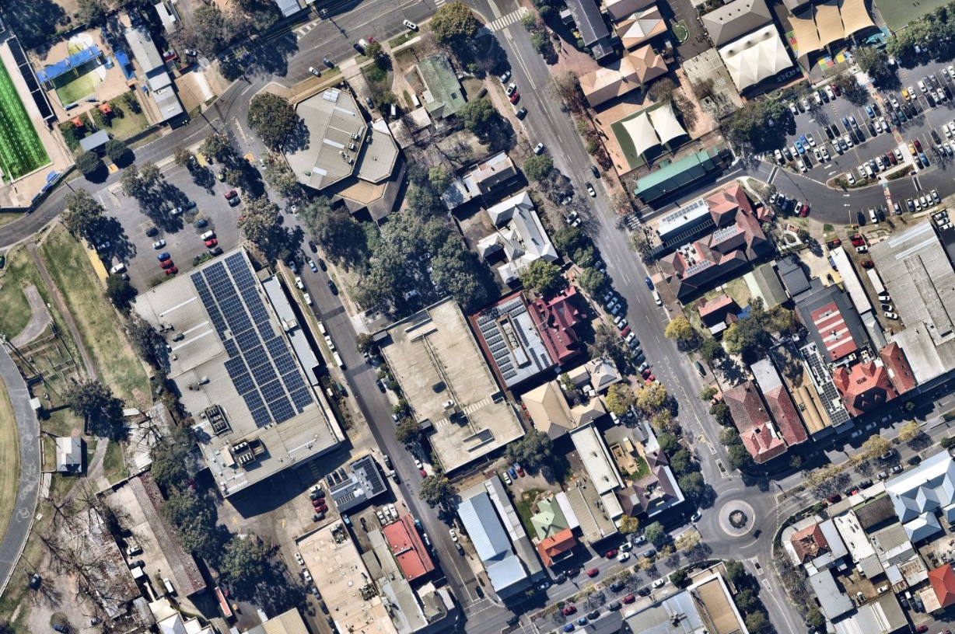

The Site

The site comprises a single property that is commonly known as 40-46 Oxley Street, Camden and is legally described as Lot 1 in Deposited Plan 1234107 (highlighted in red above).

The site is irregular in shape and has a frontage of 159.955 metres to Oxley Street along the western boundary, 40.58 metres to Mitchell Street along the northern boundary and 15.24 metres to John Street along the eastern boundary and a total area of 6,848m².

The works proposed in the subject DA relate to the existing Civic Centre building positioned in the north-western corner of the site at the corner intersection of Oxley Street and Mitchell Street and the adjacent Memorial Garden located on the eastern side of the site fronting John Street. The application does not propose any work on the southern portion of the site that contains the multi level car park.

The surrounding area is characterised by commercial land uses to the west and south and educational, recreational and cultural land uses to the north and east. A mix of land uses surround the site including a standalone Woolworths supermarket above a car parking level opposite to the west on Oxley Street; Camden Public School and Camden War Memorial Pool opposite to the north on Mitchell Street; and Camden Local Court, Uniting Church, St Paul’s Catholic Church, Camden Museum and Camden Library to the east.

The wider local area is characterised as the Camden Town Centre comprising a street shopping strip along Argle Street and a mixture of commercial/retail, cultural, educational, recreational and residential land uses in the connecting streets.

A location map and photos showing the location of the site from the surrounding streets are provided below for context:

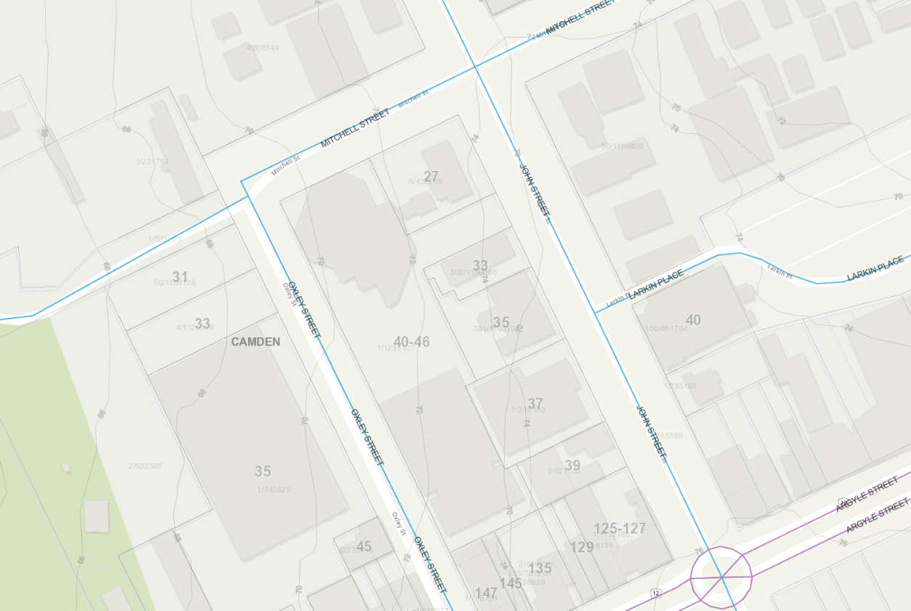
Figure 1: Location Map of the site
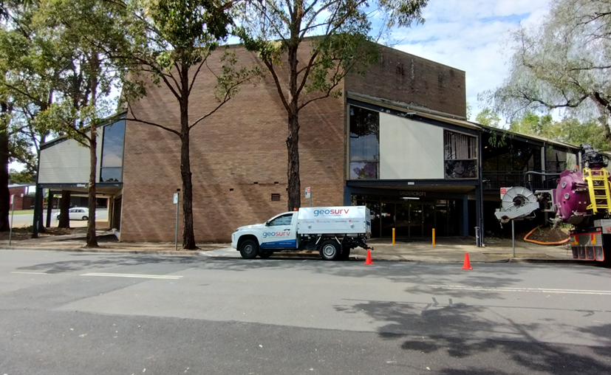
Figure 2: View of the Civic Centre from Oxley Street
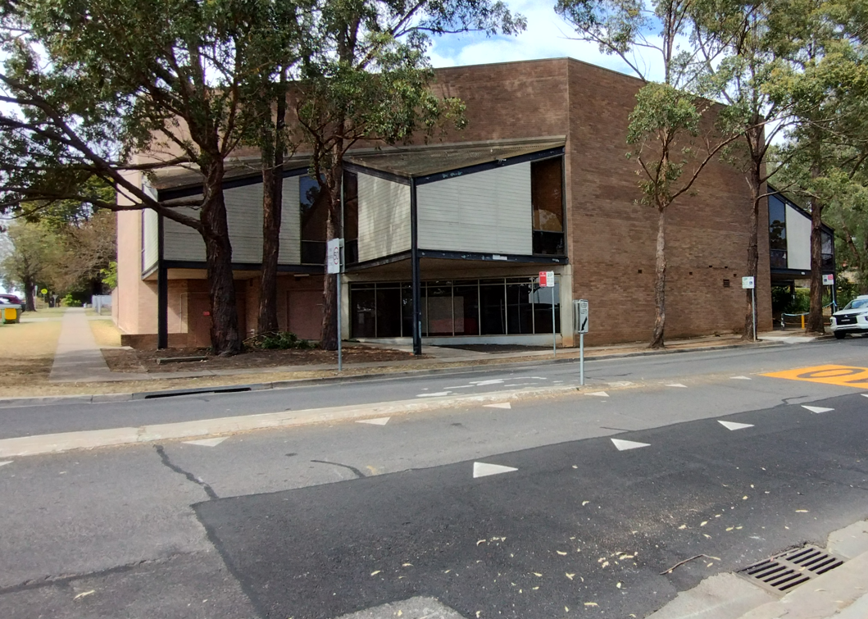
Figure 3: View of the Civic Centre from Oxley/Mitchell Street Corner
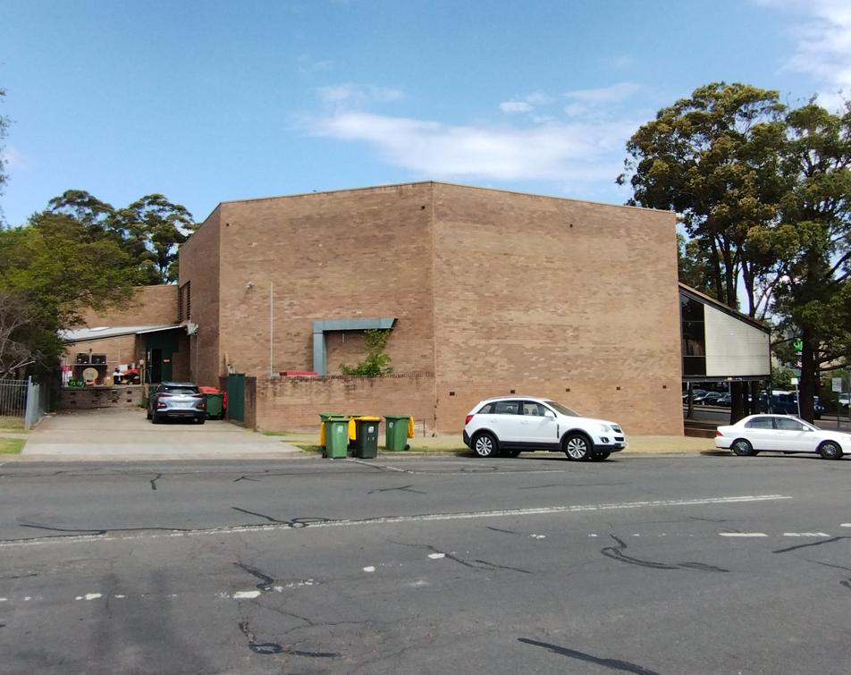
Figure 4: View of the Civic Centre from Mitchell Street
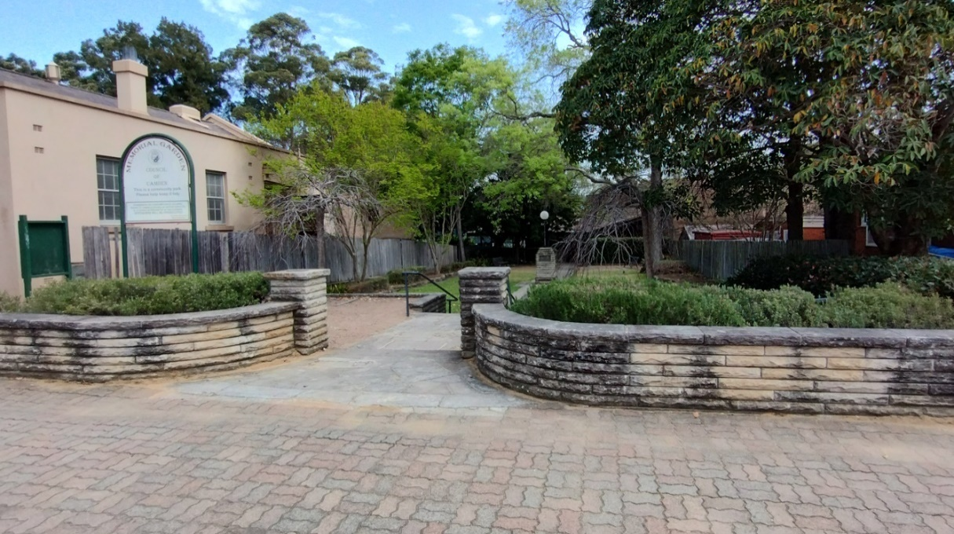
Figure 5: View of the Memorial Garden/Site from John Street
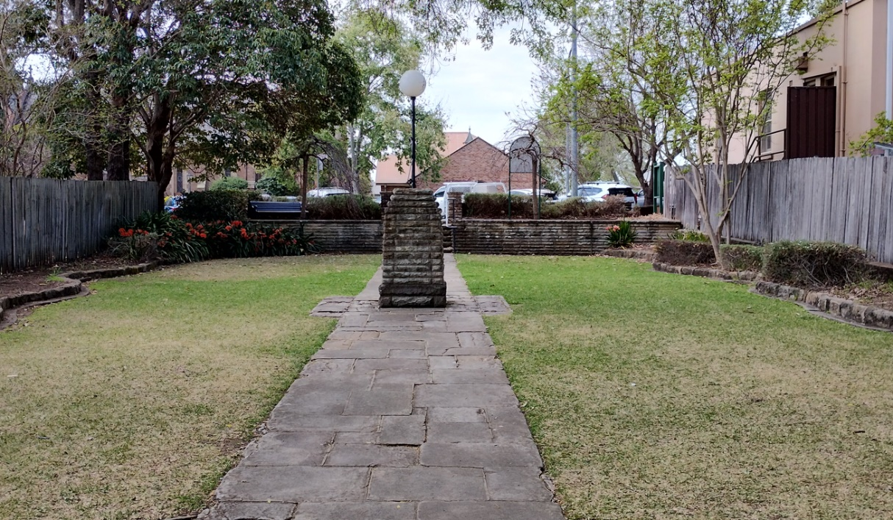
Figure 6: View of the Memorial Garden Looking toward John Street
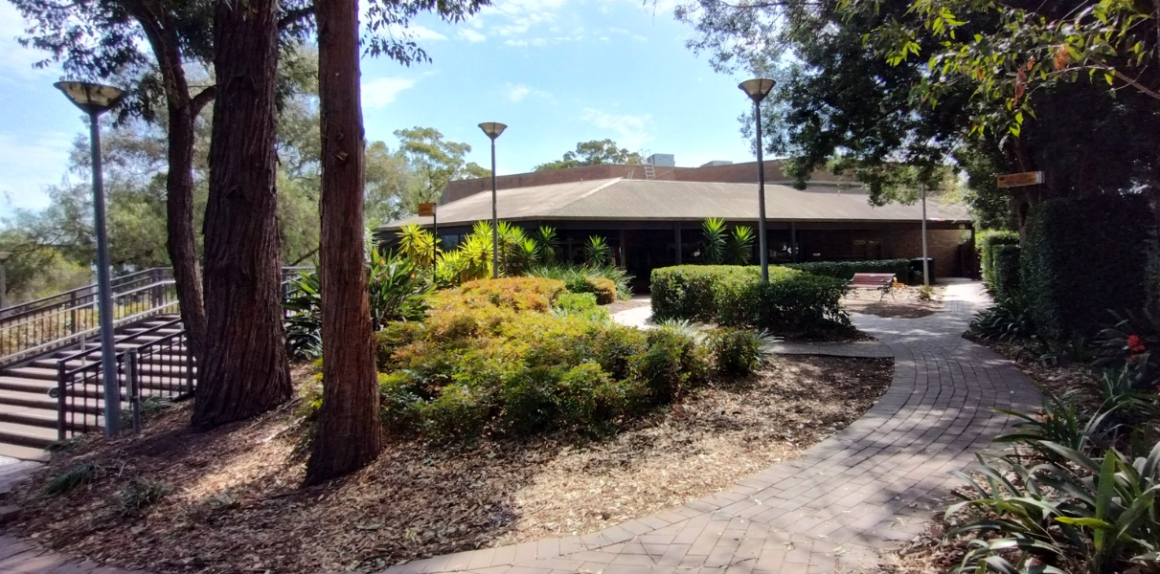
Figure 7: View of the Civic Centre building from car park
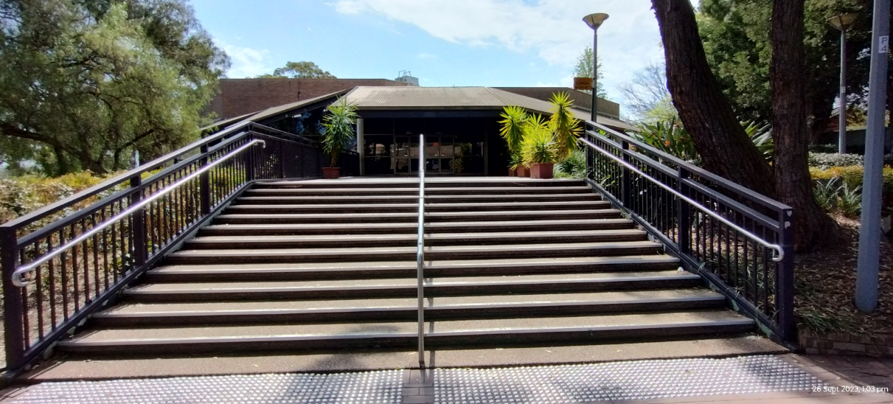
Figure 8: View of existing stair access to Civic Centre building from car park

History

There is no recent DA history related to the site.

Zoning Plan

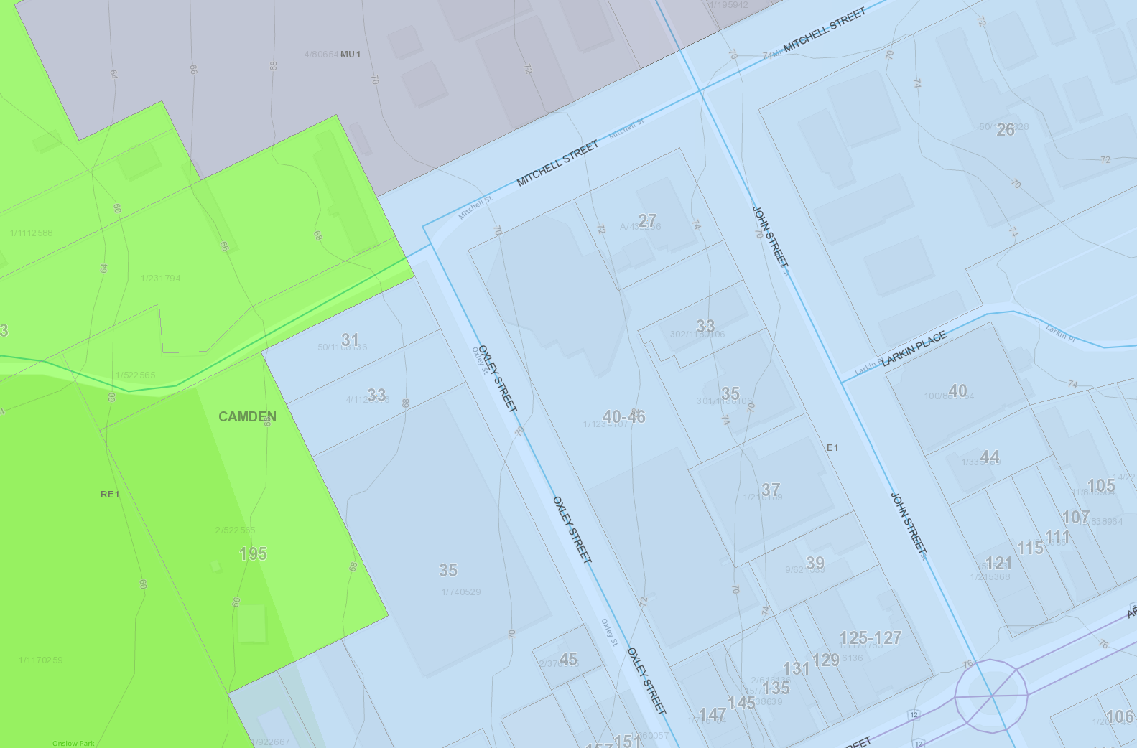
MU1
E1
RE1
Figure 9: Camden LEP Land Use Zoning Map Extract
THE PROPOSAL

DA/2023/284/1 seeks approval for alterations and additions to Camden Civic Centre, including construction of a new building entry, extension of the building foyer, internal refurbishment and reconfiguration, erection of signage, removal of six trees and landscaping within the building curtilage and the Memorial Garden.

Specifically, the development involves:

- Construction of a new building entry on the ground floor south-eastern corner of the building comprising a new entry verandah, paving, lighting and wayfinding;

- Additions to the existing building that will extend the existing building foyer and enclose an existing balcony on the south-eastern corner of the building and extension to the existing store room at the north-western corner of the building;

- Proposed new bar contained within the foyer area;

- Internal refurbishment and reconfiguration of the existing spaces on the lower ground floor including:

  - Reconfigured male and female WC’s including construction of a new accessible WC;
  - Reconfigured foyer into multi-purpose exhibition space and art maker and practice space including replacement flooring, ceilings and lighting upgrades;
  - Reconfigured existing Oxley Room to create a proposed digital recording studio and breakout space including replacement ceilings, acoustic treatment and lighting upgrades;
  - Reconfigured existing Mitchell Room to create Mitchell Function Room and multi-purpose space including replacement ceilings, acoustic treatment and lighting upgrades; and
  - Creation of cultural resources store rooms at the rear of the Mitchell Function Room.

- Internal refurbishment and reconfiguration of the existing spaces on the ground floor including:

  - Reconfigured concierge desk/office space at entry foyer;
  - Alterations and upgrades to existing foyer including air-conditioning, lighting, finishes and security;
  - Demolition of internal walls to create a bar store room;
  - Demolition of internal walls to existing bar and with re-fitout of existing bar;
  - Creation of new airlock between existing bar, kitchen and art gallery;
  - Alterations and upgrades to existing art gallery and auditorium including acoustic treatment, lighting, finishes and security; and
  - Other minor works including sealing of some internal doors and installation of new acoustic doors.

- Internal refurbishment and reconfiguration of the existing spaces on the first floor including:

  - Removal of 1 bathroom and extension of existing green rooms;
  - Refurbishment of existing bathroom; and
  - Cleaning of existing skylights and upgrades of lighting.

- External refurbishment including:

  - Removal of existing stairs on southern side entry and replacement with drop off area adjacent to car park;
  - Creation of a new outdoor performance space adjacent to proposed drop off area;
  - Construction of associated pathways;
  - Alterations to existing memorial garden including reconfigured pathways and garden beds, relocated memorial and construction of accessible pathways; and
  - Erection of signage, including building identification signs, business identification signs and wayfinding signage.

- Removal of six trees; and

- Landscaping within the building curtilage and Memorial Garden.

PANEL BRIEFING

Council staff briefed the DA to the Panel on 26 June 2023. The Panel did not raise any specific issues at the briefing regarding the proposal however suggested that the opportunity for an architectural quality peer review be investigated.

The proposed development was independently reviewed by a Heritage Consultant (City Plan), who was generally supportive of the development and has provided the following comments in respect to the buildings architectural form;

In general, the design of the propose alterations and additions, by Melocco & Moore respects the late twentieth century Sydney regional style of the building and follows the triangular geometrical elements that give the asymmetrical massing and emphasis the function of the spaces where visible externally.

The proposed demolition both internally and externally are considered minor with no adverse impact on the overall character and design intent of the building. While removal of the entrance stairs can be seen as an impact, its grand scale with no particular architectural value to the building and limited access from the Memorial Gardens justifies its removal for a more improved connectivity with the Memorial Garden and John Street. The new entrance structure and canopy allows for a direct orientation to the Memorial Garden and clear identification to the main entry of the Civic Centre.

The proposed materials and finishes are complementary and consistent with the existing facebrick, metal framing and cladding of the building. Introduction of the Camden Council’s Corporate style and colours in a new façade elements of the building in particular at the new entrance canopy form the pathway leading to John Street in a triangular form is appropriate.

ASSESSMENT

Environmental Planning and Assessment Act 1979 - Section 4.15(1)

In determining a DA, the consent authority is to take into consideration such of the following matters as are of relevance to the development the subject of the DA:

(a)(i) the provisions of any environmental planning instrument

The environmental planning instruments that apply to the development are:

- State Environmental Planning Policy (Planning Systems) 2021.
- Camden Local Environmental Plan 2010.
- State Environmental Planning Policy (Resilience and Hazards) 2021.
- State Environmental Planning Policy (Industry and Employment) 2021.
- State Environmental Planning Policy (Biodiversity and Conservation) 2021.

State Environmental Planning Policy (Planning Systems) 2021 (Planning Systems SEPP)

The Planning Systems SEPP identifies development that is State significant development, infrastructure and critical infrastructure and regionally significant development.

Pursuant to Schedule 6 of the Planning Systems SEPP, the Panel is the consent authority for this DA as the CIV of the development is over $5 million which is above the CIV threshold for Council to determine a DA for Council related development.

Camden Local Environmental Plan 2010 (CLEP)

The Camden LEP aims to make local environmental planning provisions for land in Camden.

Site Zoning

The site is zoned E1 Local Centre pursuant to the land use table of the Camden LEP.

Development Characterisation

The development is characterised as alterations and additions to an existing ‘community facility’, being the Camden Civic Centre, pursuant to the dictionary to the Camden LEP.

Permissibility

All of the development is permitted with consent in the zone in which it is proposed pursuant to the land use table of the Camden LEP.

Planning Controls

An assessment table in which the development is considered against the Camden LEP’s planning controls is provided as an attachment to this report.

State Environmental Planning Policy (Resilience and Hazards) 2021 (Resilience and Hazards SEPP)

The Resilience and Hazards SEPP regulates hazardous and offensive development and aims to ensure that the consent authority has sufficient information to assess whether or not development is hazardous or offensive. The Resilience and Hazards SEPP also provides a Statewide planning approach to the remediation of contaminated land.

Hazardous and Offensive Development

Chapter 3 of the Resilience and Hazards SEPP requires the consent authority to assess whether or not the development stores or requires the transport of dangerous goods above its screening thresholds. If any of the Resilience and Hazards SEPP thresholds are breached, the consent authority must then determine whether or not the development is hazardous or offensive by considering the measures proposed to reduce the impact of the dangerous goods.

Based on the scope of work proposed and the ‘community facility’ land use, the development is not considered to be hazardous or offensive development as defined by the Resilience and Hazards SEPP.

Contaminated Land

Section 4.6 of the Resilience and Hazards SEPP requires the consent authority to consider if the site is contaminated. If the site is contaminated, the consent authority must be satisfied that it is suitable in its contaminated state for the development. If the site requires remediation, the consent authority must be satisfied that it will be remediated before the land is used for the development. Furthermore, the consent authority must consider a preliminary contamination investigation in certain circumstances.

A Geotechnical Investigation Report was prepared and submitted in support of the DA which adequately assesses the potential contamination of the land. The report concludes that concentrations of all contaminants found in soil tests were very low and below the criteria for the development. An assessment and review of the report agrees with its findings and satisfactorily establishes that the site is suitable for the development.

A standard contingency condition is recommended that requires any contamination found during works to be managed with development consent obtained for remediation if required.

State Environmental Planning Policy (Industry and Employment) 2021 (Industry and Employment SEPP)

The Industry and Employment SEPP aims to ensure that signage is compatible with the desired amenity and visual character of an area, provides effective communication in suitable locations and is of high quality design and finish.

Section 3.6 of the Industry and Employment SEPP requires the consent authority to be satisfied that signage is consistent with the objectives as set out in Section 3.1(1)(a) of the SEPP and the assessment criteria specified in Schedule 5 of the SEPP.

The application proposes various signage distributed around the site including:

- Site, destination, zone, room and toilet ID signage;
- Directional ID signage;
- Operational and privacy decal operational signage;
- Interpretive signage; and
- 3 x banners on the Oxley Street elevation.

The application was accompanied by an assessment of the proposed signage against the SEPP and DCP and an assessment table in which the development is considered against these matters is provided as an attachment to this report.

State Environmental Planning Policy (Biodiversity and Conservation) 2021 (Biodiversity and Conservation SEPP)

The removal of six (6) trees is considered satisfactory for the purpose of developing the Civic Centre and will have a minimal impact on the overall amenity of the Civic Centre.

The development is considered satisfactory in terms of the matters for consideration in Chapter 6 of the Biodiversity and Conservation SEPP. There will be no unreasonable adverse impacts upon the Hawkesbury-Nepean Catchment as a result of the development.

(a)(ii) the provisions of any proposed instrument that is or has been the subject of public consultation under this Act and that has been notified to the consent authority (unless the Secretary has notified the consent authority that the making of the proposed instrument has been deferred indefinitely or has not been approved)

Draft Remediation of Land State Environmental Planning Policy (Draft Remediation of Land SEPP)

The development is consistent with the Draft Remediation of Land SEPP in that it is consistent with the Resilience and Hazards SEPP.

(a)(iii) the provisions of any development control plan

The development control plan that applies to the development is Camden Development Control Plan 2019 as addressed below.

Camden Development Control Plan 2019 (Camden DCP)

Planning Controls

An assessment table in which the development is considered against the Camden DCP is provided as an attachment to this report.

(a)(iiia) the provisions of any planning agreement that has been entered into under section 7.4, or any draft planning agreement that a developer has offered to enter into under section 7.4

No relevant planning agreement or draft planning agreement exists or has been proposed as part of this DA.

(a)(iv) the regulations (to the extent that they prescribe matters for the purposes of this paragraph)

The Environmental Planning and Assessment Regulation, 2021 prescribes several matters that are addressed in the conditions attached to this report.

(b) the likely impacts of the development, including environmental impacts on both the natural and built environments, and social and economic impacts in the locality

As demonstrated by the assessment and further summarised below, the development is unlikely to have any unreasonable adverse impacts on either the natural or built environments, or the social and economic conditions in the locality.

Context & Setting

The proposal is appropriately sited, observes a high standard of design and proposes a development that will be compatible with the local area and the desired future character of the local area.

The proposal has been designed to integrate and be consistent with the character of development envisaged in the local area with the development complementing the setting and context of the area.

The overall built form maintains the existing building envelope with minor additions that would not radically transform the building in the setting and context. As detailed within this report, no variations are sought to the controls prescribed in the Camden LEP and Camden DCP, indicating that the proposal is an appropriate site responsive design.

Access, Transport and Traffic

The application proposes building and site works that will provide for better and wider accessibility into, within and throughout the site and building.

Utilities

The augmentation of existing utilities and infrastructure may be necessary as a result of the proposal and will be borne by the person acting on any consent granted subject to conditions of development consent.

Heritage

The subject site is not identified as a Heritage Item however is located within the Camden Town Centre Heritage Conservation Area and is within proximity to a number of heritage items including:

- John Street, Camden Public School (I41A);
- 33 John Street, Camden Court House (I43);
- 35 John Street, Camden Police Station and Residence (I44);
- 37 John Street, Camden Macari (I45); and
- 39 John Street, Camden Cottage (I46).

The application was accompanied by a Heritage Impact Statement prepared by John Oultram Heritage & Design which has been independently peer reviewed by City Plan and considered acceptable. Suitable conditions have been recommended which have been incorporated into the recommended conditions of consent.

Tree Removal, Landscaping, Flora & Fauna

The application proposes removal of six (6) trees and landscaping works surrounding the site. The proposed works were reviewed by Council’s Urban Tree and Landscaping Office who supports the proposal and recommended conditions which have been incorporated into the recommended conditions of consent.

Overall, and having regard to the proposal, no significant impact on flora and fauna is envisaged as a result of the proposed development.

Noise and Vibration

All work will be required to be undertaken during conditioned work hours as specified in the development consent. Subject to compliance with the conditions, noise and vibration impacts are not anticipated.

Natural Hazards

The subject site is not identified as being affected by bushfire, flooding, landslip or subsidence.

Social and Economic Impacts

The proposal is considered to provide positive social and short and long-term economic benefits for the local and wider community given that it is related to a community related land use.

Construction

All construction work will be undertaken in accordance with conditions of consent, and the stamped plans, which will ensure that construction impacts are not anticipated to have an adverse impact on the locality.

Cumulative Impacts

It is considered there will be no negative cumulative impacts as a result of the proposed development.

All other likely impacts have been assessed in other sections of this report.

(c) the suitability of the site for the development

As demonstrated by the assessment, the site is considered to be suitable for the development.

(d) any submissions made in accordance with this Act or the regulations

The DA was publicly exhibited for a period of 35 days in accordance with Camden Community Participation Plan 2021. The exhibition period was from 5 June to 30 July 2023. Three submissions were received (objecting to the development and raising matters for consideration).

The following discussion addresses the issues raised in the submissions.

- Need for the proposed upgrades and other priority works within the LGA.

Officer comment:

The need for the proposed upgrades and the submitters request for other works within the LGA to be given priority are not matters for consideration of the application pursuant to Section 4.15 of the Act.

- Concerns about the changes to the Memorial Park and sensitivity to existing cairn, stones and paving being retained and re-used.

Officer comment:

The application was accompanied by a Heritage Impact Statement prepared by John Oultram Heritage & Design which has been independently peer reviewed by City Plan and considered acceptable. Suitable conditions have been recommended which have been incorporated into the recommended conditions of consent.

- Public art installations and signage on John Street have regard to HCA.

Officer comment:

The application was accompanied by a Heritage Impact Statement prepared by John Oultram Heritage & Design which has been independently peer reviewed by City Plan and considered acceptable. Suitable conditions have been recommended which have been incorporated into the recommended conditions of consent.

- Finishes palette, modern style, signage and additions to the building unsympathetic within the HCA.

Officer comment:

The application was accompanied by a Heritage Impact Statement prepared by John Oultram Heritage & Design which has been independently peer reviewed by City Plan and considered acceptable. Suitable conditions have been recommended including changes to the colour palette of some building elements which have been incorporated into the recommended conditions of consent.

- Insufficient landscaping and replacement tree canopy planting.

Officer comment:

The application was accompanied by an Arborist Report and detailed Landscape Plans that were reviewed by Council’s Urban Tree & Landscaping Officer who raised no objection and recommended conditions that have been incorporated into the recommended conditions of consent.

- Insufficient detail about John Street including perspectives.

Officer comment:

Additional information including an additional perspective from John Street were requested from the application and subsequently provided as copied below:

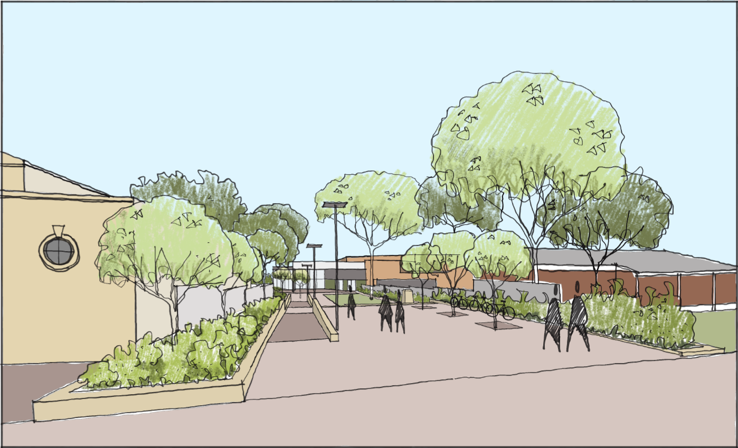
Figure 12: John Street Perspective
The perspective provides an illustrative indication of the proposed works within the Memorial Garden as viewed from John Street and considered acceptable as detailed elsewhere within this report and attachments.

(e) the public interest

The public interest is served through the detailed assessment of this DA under the Environmental Planning and Assessment Act, 1979, the Environmental Planning and Assessment Regulation, 2021, environmental planning instruments, development control plans and policies. Based on the assessment, the development is consistent with the public interest.

External REFERRALS

The external referrals undertaken for this DA are summarised in the following table:

Referral | Response
NSW Police - Camden Police Area Command (CPTED) | No objection and no conditions required.

FINANCIAL IMPLICATIONS

This matter has no direct financial implications for Council.

CONCLUSION

The DA has been assessed in accordance with Section 4.15(1) of the Environmental Planning and Assessment Act, 1979 and all relevant instruments, plans and policies. The DA is recommended for approval subject to the conditions attached to this report.

RECOMMENDATION
That the Panel:

- approve 2023/284/1 for alterations and additions to Camden Civic Centre, including construction of a new building entry, extension of the building foyer, internal refurbishment and reconfiguration, erection of signage, removal of six trees and landscaping within the building curtilage and Memorial Garden at 40-46 Oxley Street, Camden, subject to the conditions attached to this report for the following reasons:

- The development is consistent with the objectives and controls of the applicable environmental planning instruments, being State Environmental Planning Policy (Resilience and Hazards) 2021, State Environmental Planning Policy (Industry and Employment) 2021, State Environmental Planning Policy (Biodiversity and Conservation) 2021 and Camden Local Environmental Plan 2010.

- The development is consistent with the objectives of the Camden Development Control Plan 2019.

- The development is considered to be of an appropriate scale and form for the site and the character of the locality.

- Subject to the recommended conditions, the development is unlikely to have any unreasonable adverse impacts on the natural or built environments.

- For the above reasons, the development is a suitable use of the site and its approval is in the public interest.

